##### **MCSP - 060**

##### **Banking Portal**

**by**

**Name:- Gyan Ranjan**

**Enrolment No:- 161502230**

**Under Guidance**

**of**

**Abhishek Kumar**

**Submitted to the School of Computer and Information Sciences, IGNOU**

**in partial fulfilment of the requirements**

**for the award of the degree**

**Master of Computer Applications (MCA)**

**2018**



**Indira Gandhi National Open University**

**Maidan Garhi**

**New Delhi – 110068.**

**PROJECT TITLE:**

TABLE OF CONTENTS

1. SDLC
2. Introduction
3. SRS
4. Gantt Chart & PERT Chart
5. Module
6. Software And Hardware Requirements
7. Project Approach
8. Context Diagram
9. Feasibility Report
10. DFD
11. UML Diagram
12. Class Diagrams
13. Sequence Diagram
14. State Diagram
15. ER Diagram
16. Future Scope
17. Testing
18. Project Summary
19. Bibliography

**SDLC:-**

The software development life cycle (SDLC) is a framework defining tasks performed at each step in the software development process. SDLC is a structure followed by a development team within the software organization. It consists of a detailed plan describing how to develop, maintain and replace specific software. The life cycle defines a methodology for improving the quality of software and the overall development process.

The software development life cycle is also known as the software development process.

**SDLC consists of following activities:**

1. Planning: The most important parts of software development, requirement gathering or requirement analysis are usually done by the most skilled and experienced software engineers in the organization. After the requirements are gathered from the client, a scope document is created in which the scope of the project is determined and documented.
2. Implementation: The software engineers start writing the code according to the client's requirements.
3. Testing: This is the process of finding defects or bugs in the created software.
4. Documentation: Every step in the project is documented for future reference and for the improvement of the software in the development process. The design documentation may include writing the application programming interface (API).
5. Deployment and maintenance: The software is deployed after it has been approved for release.
6. Maintaining: Software maintenance is done for future reference. Software improvement and new requirements (change requests) can take longer than the time needed to create the initial development of the software.

**INTRODUCTION:**

The Multi Banking System Interface is targeted to the future banking solution for the users who is having multiple bank accounts in multiple banks. This interface integrates all existing banks and provides business solutions for both retail and corporate.

This system acts as a standard interface between the clients and all the banks, By using this portal any client who maintain accounts in various banks can directly log on to Multi Banking System Interface and make any kind of transactions. In the backend, system will take care of the entire obligation required in order to carry on transaction smoothly.

**SYSTEM REQUIREMENT SPECIFICATIONS**

**Existing System:**

Currently we are having lot of banks in the market and any person can do transactions of any individual bank either manually or in online. But no one can do all banks transactions in a single portal or in single bank. This is the main disadvantage in existing system to avoid this problem we are introducing “multi banking system”.

**Proposed System:**

The Multi Banking System Interface is targeted to the future banking solution for the users who is having multiple bank accounts in multiple banks. This interface integrates all existing banks and provides business solutions for both retail and corporate.

This system acts as a standard interface between the clients and all the banks, By using this portal any client who maintain accounts in various banks can directly log on to Multi Banking System Interface and make any kind of transactions. In the backend, system will take care of the entire obligation required in order to carry on transaction smoothly.

### Need for Computerization

Computerization is absolutely necessary to facilitate or automate various procedures and several transactions. Some salient features of computerization are:

* reduction in processing time
* data security
* reduced redundancy & inconsistency

**Gantt chart:**

The Gantt chart showing the software development plan is shown below:

Start of the Project

SRS Completion

Requirements Finalization

System Design

Detail Design

Coding

Unit Testing

Test Plan

Test*i*ng

1 Dec

20 Apr

1 Apr

15March

15 Jun

1 Feb

1 Jun

15 Dec

Time Duration of the Activity

Milestones

**PERT Chart:**

The Pert chart showing the software development plan is shown below:

# **Number of Modules**

After careful analysis the system has been identified to have the following modules:

1. **Admin Module**
2. **Customer Module**
3. **Bank Admin Module**
4. **Reports Module**

**1. Admin Module:**

The admin module will be used by the administrator of this portal, admin can accept or reject the requests from the bankers, and also admin can accept or reject the requests from the users. The requests are in the form of bank registration, customer registration. This module is having following functionalities.

* **Pending Bankers Requests:** By using this functionality Administrator can give access permeations to all bankers who are registered in this portal.
* **Pending User Requests:** By using this functionality Administrator can give access permeations to all users who are registered in this portal.

**2. Customer Module:**

This module describes all about customers, by using this module any customer can do some operations like create a new account, view the account information, Transfer amount from one account to other account and customer can also see the Transaction Reports. This module consists following functionalities.

* **Create New Account:** By using this functionality user can create a new account in any bank by selecting bank name option.
* **View Account Information:** By using this functionality user view all his account details, this can be viewed by users who are having account in any bank.
* **Transfer Amount:** By using this functionality user can transfer money from his account to other accounts of same bank or other banks.
* **Transaction Reports:** By using this functionality user can get all his transaction reports like accepted transactions, rejected transactions and pending transactions.

**3. Bank Admin Module:**

This module deals with all transactions of bank management. By using this module bank staff can view all details of customers, they can go for any transactions of their customers and also they can give access permeations to all customers of that bank. This module consists following functionalities.

* **List of Customers:** By using this functionality Bank admin can get their entire customers list and their details.
* **List of Accounts:** By using this functionality Bank admin can get their entire customers list based on selected account type like saving account, current account etc.
* **Transfer Pending:** By using this functionality Bank admin can maintain money transfer details of customers.
* **Transfer Declines:** By using this functionality Bank admin can maintain money transfer rejected customer details.
* **New Accounts Pending:** By using this functionality Bank admin can maintain entire user details who are requesting for new account in that bank.

**4. Reports Module:**

In this module administrator will get different types of reports regarding customers like Number of customers of this portal and no. of banks registered in this portal. This module is controlled by administrator only.

**Software Engineering Methodology:**

Object Oriented Analysis and Design (OOAD Standards)

**Non-Functional Requirements:**

**Software requirements**:

Operating System : Windows

Technology : Java/j2ee (JDBC, Servlets, JSP)

Web Technologies : Html, JavaScript, CSS

Web Server : Tomcat

Database : Oracle

Software’s : JDK8, Tomcat 9, Oracle 10g

**Hardware requirements**:

Hardware : Pentium based systems with a minimum of p4

RAM : 256MB (minimum)

**Additional Tools:**

HTML Designing : Dream weaver Tool

Development Tool kit : Eclipse Oxygen

**Project Approach:**

This Document plays a vital role in the development life cycle (SDLC) as it describes the complete requirements of the system. It is meant for use by the developers and will be the basic during testing phase. Any changes made to the requirements in the future will have to go through formal change approval process.

OOAD MODEL was being chosen because all requirements were known beforehand and the objective of our software development is the computerization/automation of an already existing manual working system.

**Umbrella Activity**

**Umbrella Activity**

**Umbrella Activity**

* TEAM FORMATION
* PP PREPARATION
* QP PREPARATION
* CMP PREPARATION
* FAMILIARIZATION
* START AUDIT / REVIEWS
* EFFORT CAPTURE
* STATUS REPORTS
* QD CONSOLIDATION
* STATUS REVIEW
* CHANGE REQUEST HANDLING

DESIGN & ANALYSIS

CODE

UNIT TEST

DOCUMENT CONTROL

* ASSESSMENT
* END AUDIT

TRAINING

INTEGRATION & SYSTEM TEST

DELIVERY/ INSTALLATION

ACCEPTANCE

REQUIREMENTS STUDY

**Fig: SDLC Model**

The developer is responsible for:

* Developing the system, which meets the SRS and solving all the requirements of the system?
* Demonstrating the system and installing the system at client's location after the acceptance testing is successful.
* Submitting the required user manual describing the system interfaces to work on it and also the documents of the system.
* Conducting any user training that might be needed for using the system.
* Maintaining the system for a period of one year after installation.

**INPUT DESIGN:**

Input design is a part of overall system design. The main objective during the input design is as given below:

* To produce a cost-effective method of input.
* To achieve the highest possible level of accuracy.
* To ensure that the input is acceptable and understood by the user.

**INPUT STAGES:**

The main input stages can be listed as below:

* Data recording
* Data transcription
* Data conversion
* Data verification
* Data control
* Data transmission
* Data validation
* Data correction

**OUTPUT DESIGN:**

Outputs from computer systems are required primarily to communicate the results of processing to users. They are also used to provide a permanent copy of the results for later consultation. The various types of outputs in general are:

* External Outputs whose destination is outside the organization.
* Internal Outputs whose destination is with in organization and they are the User’s main interface with the computer.
* Operational outputs whose use is purely with in the computer department.
* Interface outputs, which involve the user in communicating directly with the system.

Keeping in view the above description the project is to have outputs mainly coming under the category of internal outputs. The main outputs desired according to the requirement specification are:

The outputs were needed to be generated as a hard copy and as well as queries to be viewed on the screen. Keeping in view these outputs, the format for the output is taken from the outputs, which are currently being obtained after manual processing. The standard printer is to be used as output media for hard copies.

**Context Diagram:**

Admin

Controlling both banks & customers

Register

Register

0

**Multi Banking**

**System**

Customers

Banks

Customer interaction

Bank transactions



Stores data

**Performance Requirements:**

Performance is measured in terms of the output provided by the application. Requirement specification plays an important part in the analysis of a system. Only when the requirement specifications are properly given, it is possible to design a system, which will fit into required environment. It rests largely with the users of the existing system to give the requirement specifications because they are the people who finally use the system. This is because the requirements have to be known during the initial stages so that the system can be designed according to those requirements. It is very difficult to change the system once it has been designed and on the other hand designing a system, which does not cater to the requirements of the user, is of no use.

The requirement specification for any system can be broadly stated as given below:

* The system should be able to interface with the existing system
* The system should be accurate
* The system should be better than the existing system

The existing system is completely dependent on the user to perform all the duties.

**Feasibility Report:**

Preliminary investigation examines project feasibility, the likelihood the system will be useful to the organization. The main objective of the feasibility study is to test the Technical, Operational and Economical feasibility for adding new modules and debugging old running system. All systems are feasible if they are given unlimited resources and infinite time. There are aspects in the feasibility study portion of the preliminary investigation:

* Technical Feasibility
* Operation Feasibility
* Economical Feasibility

**Technical Feasibility:**

The technical issue usually raised during the feasibility stage of the investigation includes the following:

* Does the necessary technology exist to do what is suggested?
* Do the proposed equipments have the technical capacity to hold the data required to use the new system?
* Will the proposed system provide adequate response to inquiries, regardless of the number or location of users?
* Can the system be upgraded if developed?
* Are there technical guarantees of accuracy, reliability, ease of access and data security?

**Operational Feasibility:**

Proposed projects are beneficial only if they can be turned out into information systems, that will meet the organization’s operating requirements. Operational feasibility aspects of the project are to be taken as an important part of the project implementation. Some of the important issues raised are to test the operational feasibility of a project includes the following: -

* Is there sufficient support for the management from the users?
* Will the system be used and work properly if it is being developed and implemented?
* Will there be any resistance from the user that will undermine the possible application benefits?

This system is targeted to be in accordance with the above-mentioned issues. Beforehand, the management issues and user requirements have been taken into consideration. So there is no question of resistance from the users that can undermine the possible application benefits.

The well-planned design would ensure the optimal utilization of the computer resources and would help in the improvement of performance status.

**Economic Feasibility:**

A system can be developed technically and that will be used if installed must still be a good investment for the organization. In the economical feasibility, the development cost in creating the system is evaluated against the ultimate benefit derived from the new systems. Financial benefits must equal or exceed the costs. The system is economically feasible. It does not require any additional hardware or software.

**DFD DIAGRAMS:**

**Context Level Dfd**

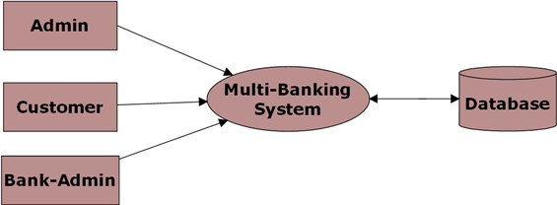

**Level 0 DFD for Admin:**

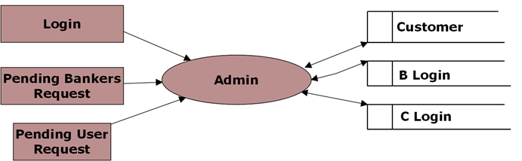

**Level 0 DFD for Customer:**

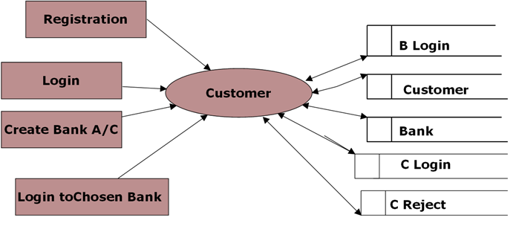

**Level 0 DFD for Bank Admin:**

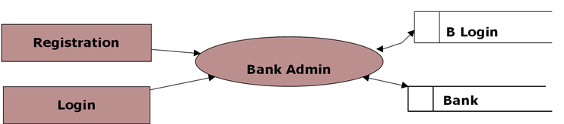

**Level 1 DFD for Chosen Bank:**

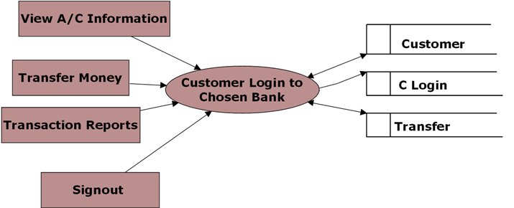

**Level 1 DFD for Banker Login:**

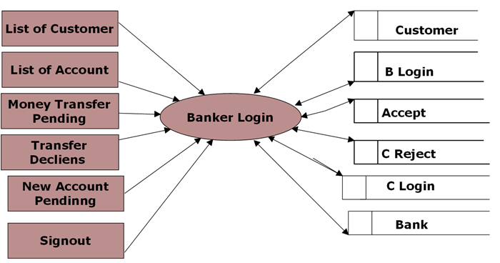

**Level 2 for Money Transfer:**

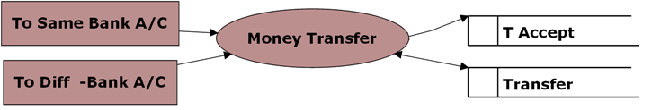

**Level 2 DFD for Transaction Reports:**

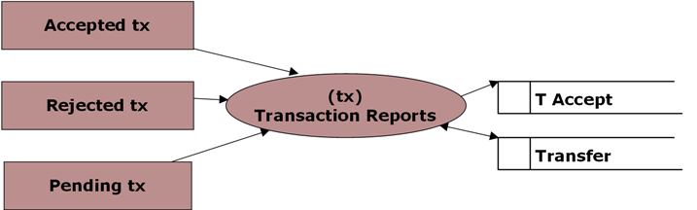

**UML DIAGRAMS**

**Unified Modeling Language**:

The Unified Modeling Language allows the software engineer to express an analysis model using the modeling notation that is governed by a set of syntactic semantic and pragmatic rules.

A UML system is represented using five different views that describe the system from distinctly different perspective. Each view is defined by a set of diagram, which is as follows.

* + User Model View
  + Structural model view
* Behavioral Model View
* Implementation Model View
* Environmental Model View

UML is specifically constructed through two different domains they are:

* UML Analysis modeling, this focuses on the user model and structural model views of the system.
* UML design modeling, which focuses on the behavioral modeling, implementation modeling and environmental model views.

**UML DIAGRAMS**

**Use Case Diagram for Administrator:**

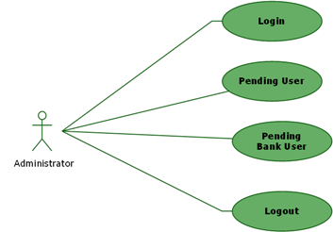

**Use Case Diagram for Bank Administrator**:

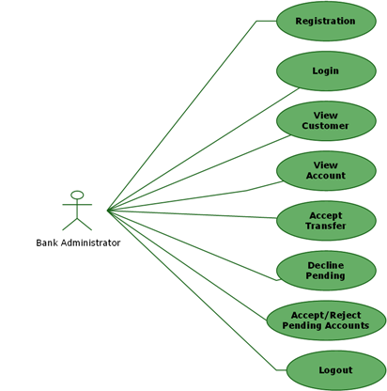

**Use Case Diagram for A/C Holder:**

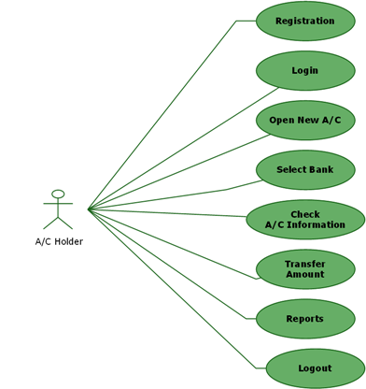

**Class Diagram:**

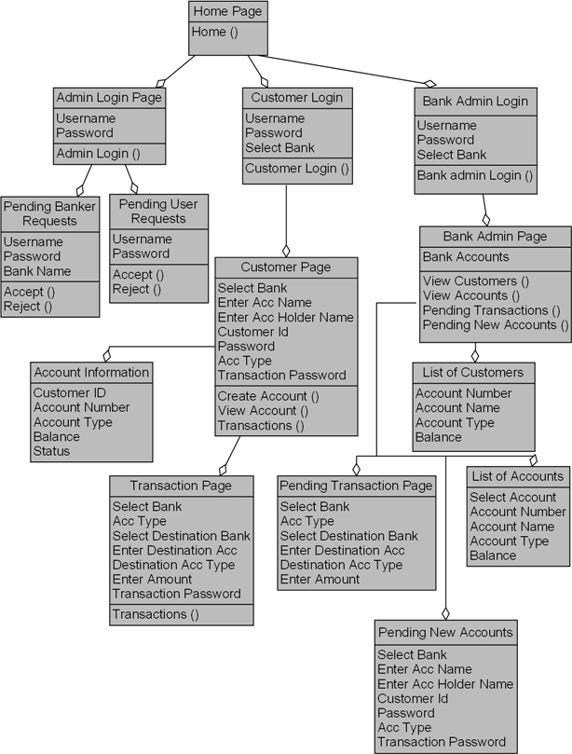

**Sequence Diagram for Admin:**

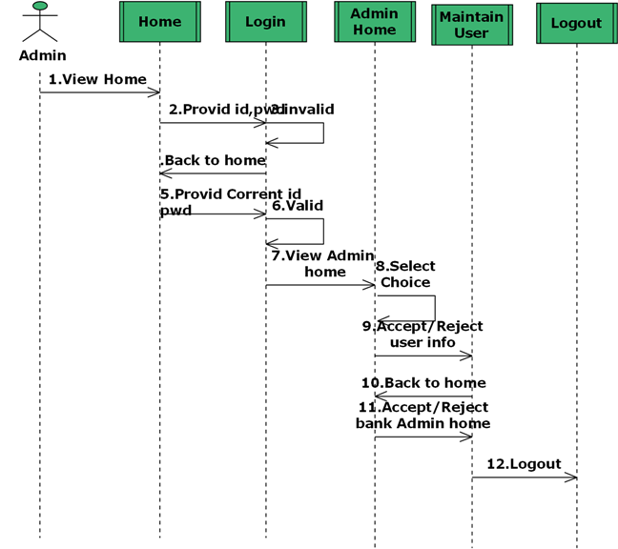

**Sequence Diagram for Bank Admin:**

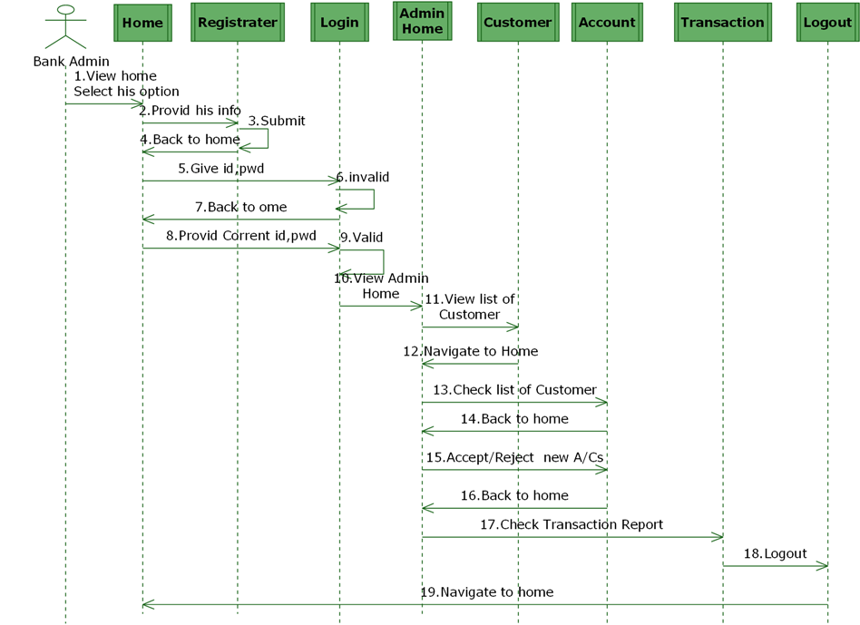

**Sequence Diagram for Customer:**

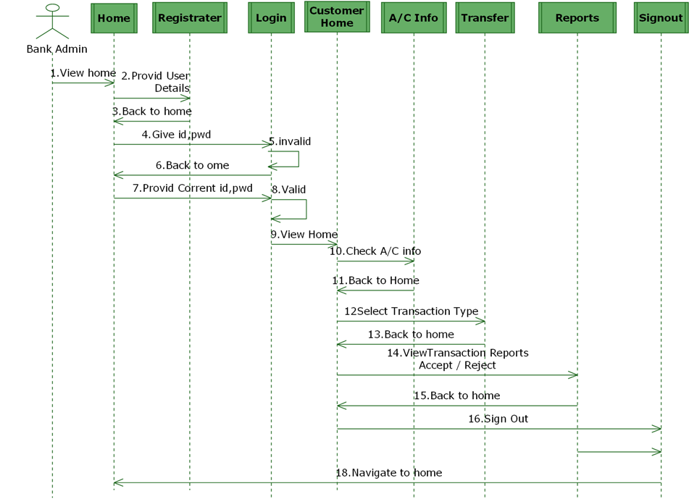

**State Diagram for Admin**

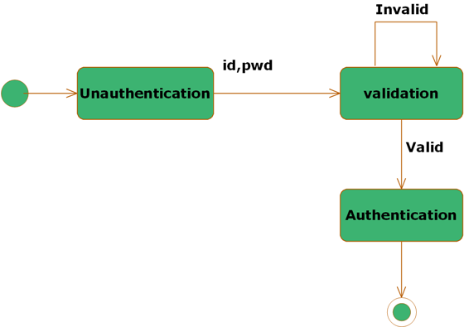

**State Diagram for Customer**

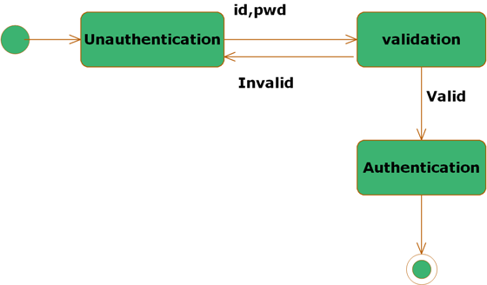

**State Diagram for Bank Admin:**



**ER DIAGRAMS**

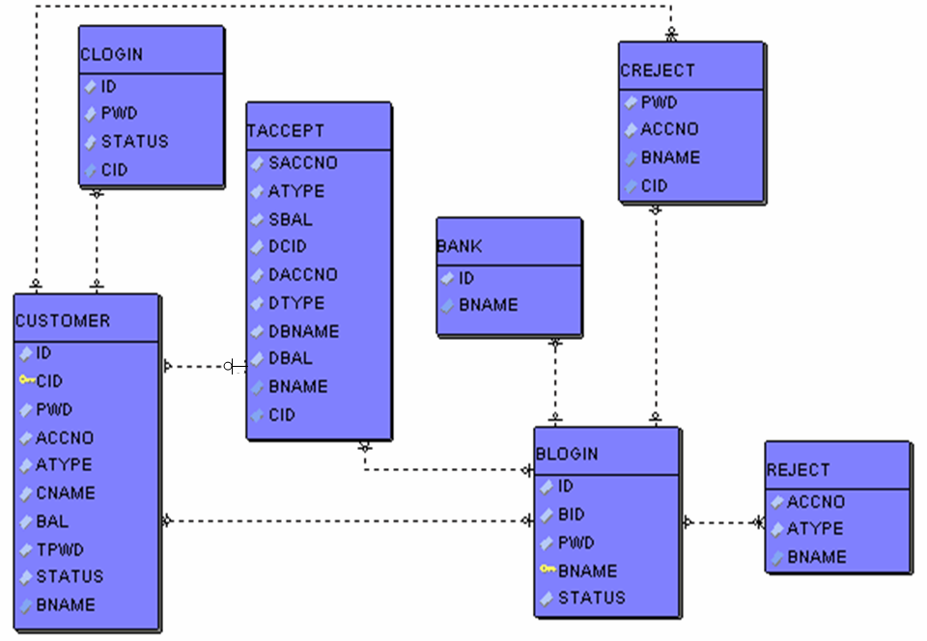

**Future Scope:**

While at first the system will specialize in client based operation, in the future it is expected to be able to:

1) Transfer money of one bank to another bank.

2) For online working related to Bank. For example, opening account in any bank, Transfer money to one bank to another bank.

3) Easier way to handle.

4) So now this website is going to be a free services website.

**TESTING:**

Software Testing is the process used to help identify the correctness, completeness, security, and quality of developed computer software. Testing is a process of technical investigation, performed on behalf of stakeholders, that is intended to reveal quality-related information about the product with respect to the context in which it is intended to operate. This includes, but is not limited to, the process of executing a program or application with the intent of finding errors. Quality is not an absolute; it is value to some person. With that in mind, testing can never completely establish the correctness of arbitrary computer software; testing furnishes a criticism or comparison that compares the state and behavior of the product against a specification. An important point is that software testing should be distinguished from the separate discipline of Software Quality Assurance (SQA), which encompasses all business process areas, not just testing.

There are many approaches to software testing, but effective testing of complex products is essentially a process of investigation, not merely a matter of creating and following routine procedure. One definition of testing is "the process of questioning a product in order to evaluate it", where the "questions" are operations the tester attempts to execute with the product, and the product answers with its behavior in reaction to the probing of the tester[citation needed]. Although most of the intellectual processes of testing are nearly identical to that of review or inspection, the word testing is connoted to mean the dynamic analysis of the product—putting the product through its paces. Some of the common quality attributes include capability, reliability, efficiency, portability, maintainability, compatibility and usability. A good test is sometimes described as one which reveals an error; however, more recent thinking suggests that a good test is one which reveals information of interest to someone who matters within the project community.

**Project Summary:**

This project Banking Portal for Improving Software Quality and Reliability is to keep track of employee skills and based on the skills assigning of the task is done to an employee. User does all task releatedd to bank. It can be done on daily basis. Various operations are performed by user.

This project will be accessible to all users and its facility allows to perform multiple operation related to bank. All the data stored in the database schema and while letting the application server define table based on the fields in JSP and relationships between them.

This application software has been computed successfully and was also tested successfully by taking “test cases”. It is user friendly, and has required options, which can be utilized by the user to perform the desired operations.

The software is developed using Java as front end and Oracle as back end in Windows environment. The goals that are achieved by the software are:.

* Improved tourism.
* Optimum utilization of resources.
* Efficient management of records.
* Simplification of the operations.
* Less processing time and getting required information.
* User friendly.
* Portable and flexible for further enhancement.

**BIBLIOGRAPHY**

References for the Project Development Were Taken From the following Books and Web Sites.

JAVA Technologies

JAVA Complete Reference

Java Script Programming by Yehuda Shiran

Mastering JAVA Security

JAVA2 Networking by Pistoria

JAVA Security by Scotl oaks

Head First EJB Sierra Bates

J2EE Professional by Shadab siddiqui

JAVA server pages by Larne Pekowsley

JAVA Server pages by Nick Todd

HTML

HTML Black Book by Holzner

JDBC

Java Database Programming with JDBC by Patel moss.

Software Engineering by Roger Pressman

**SCHOOL OF COMPUTER AND INFORMATION SCIENCES**

**IGNOU, MAIDAN GARHI, NEW DELHI – 110 068**

***(Note:* *All entries of the proforma of approval should be filled up with appropriate and complete information.***

***Incomplete proforma of approval in any respect will be summarily rejected.)***

**Enrolment No. 161502230**

**Project Proposal No :…………………..**

***(for office use only)***

**Study Centre: 39015p**

Regional Centre: Noida RC Code: 39

**E-mail: gyanranjan.java@gmail.com**

**Mobile/Tel No.: 7836093096**

1. Name and Address of the Student Gyan Ranjan

Address-E-304, sector-15 Noida , UP., 201301

2. Title of the Project Banking Portal

3. Name and Address of the Guide Abhishek Kumar

Addres-E-601,JM AROMA,Sector-75, Noida ,201301

Ph.D**\***  M.Tech.**\*** B.E\***/**B.Tech.**\***  MCA M.Sc.**\***

4. Educational Qualification of the Guide

T

(Attach bio-data also)

**(*in Computer Science / IT only)**

5. Working / Teaching experience of the Guide**\*\*** Senior Software Engineer in **Impressico Business Solution Pvt Ltd**  since Aug 2016 to till date.

**(\*\**Note: At any given point of time, a guide should not provide guidance for more than 5 MCA students of IGNOU*)**

6. Software used in the Project jdk1.8, Tomcat 9.0 , Eclipse Oxygen

7. If already pursued BCA/BIT from IGNOU,

mention the title of the project (CS-76) and the s/w used……………………………………………………

8. Project title of the Mini Project (MCS-044) and the s/w used: Quiz Application

T

9. Is this your first submission? Yes No

Signature of the Student Signature of the Guide

Date: ………………… Date: …………………….

**For Office Use Only** Name:……………………………..............

…………………………………………….

Signature, Designation, Stamp of the Project Proposal Evaluator

Approved Not Approved Date: …………………….

**Suggestions for reformulating the Project:**